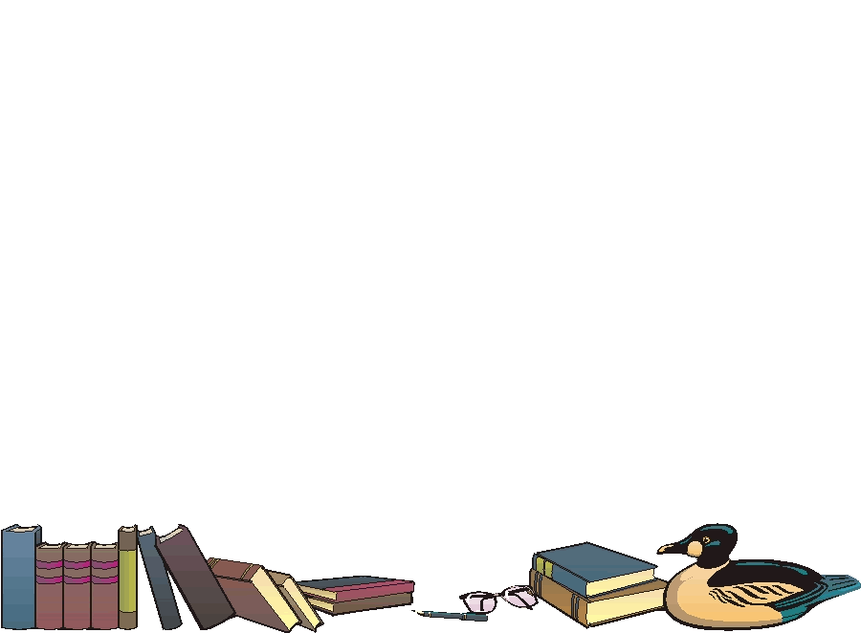

Dade County Library in Greenfield, MO is seeking applications for a part-time Children’s Librarian. Enthusiasm, Organization, good People Skills and Communication, Love of Children, and Love of Books necessary. Applicants need to have experience with technology, organizing children’s activities, and willing to assist in grant writing. Position is based on 16-24 hours/week and at least one Saturday/month. Position will begin on July 5 with training and working with current Children’s Librarian. Applications available 8:30 am-5:00 pm Monday – Friday and Saturday 8:30-12:30 at library and online at www.dadecolib.org. Applications will be accepted until Friday, June 10, 2022.